Ex.no:4b | EXPLORATORY DATA ANALYSIS (EDA) – DATA INSPECTION, FILTERING, STATISTICAL ANALYSIS AND CORRELATION

AIM

To perform data inspection, filtering, sorting, grouping, aggregation, descriptive statistical analysis, and correlation analysis on the World Happiness 2015–2024 dataset using Pandas, and to visualize the analytical results using Matplotlib and Seaborn.

ALGORITHM
Algorithm 1: Dataset Inspection
- Import the World Happiness dataset.
- Display the first few records of the dataset.
- Check the dimensions of the dataset.
- Display the data types of the attributes.
- Generate a statistical summary of the numerical attributes.
Algorithm 2: Filtering Data
- Select the required attribute.
- Specify a suitable filtering condition.
- Apply the condition to the dataset.
- Display the filtered records.
Algorithm 3: Sorting Data
- Select the attribute to be sorted.
- Apply the sort_values() function.
- Specify the sorting order.
- Display the sorted dataset.
Algorithm 4: Statistical Analysis
- Select the required numerical attribute.
- Calculate the mean.
- Calculate the median.
- Calculate the mode.
- Calculate the standard deviation.
- Display the calculated statistical measures.
Algorithm 5: Grouping and Aggregation
- Select a categorical attribute such as hotel or market segment.
- Apply the groupby() function.
- Select the required numerical attribute.
- Calculate an aggregate measure such as mean or sum.
- Display the grouped results.
Algorithm 6: Correlation Analysis
- Select the required numerical attributes.
- Apply the corr() function.
- Generate the correlation matrix.
- Analyze the correlation coefficient between the selected attributes.
- Visualize the relationship using an appropriate graph.

CODE:
# ============================================================
# EXPERIMENT 4B
# EXPLORATORY DATA ANALYSIS (EDA)
# WORLD HAPPINESS DATASET 2015-2024
# ============================================================

# ============================================================
# IMPORT LIBRARIES
# ============================================================

!pip install -q kagglehub

import kagglehub
import pandas as pd
import numpy as np
import matplotlib.pyplot as plt
import seaborn as sns
import os
import glob

# ============================================================
# LOAD DATASET FROM KAGGLE
# ============================================================

path = kagglehub.dataset_download(
"yadiraespinoza/world-happiness-2015-2024"
)

print("Dataset Path:")
print(path)

# ============================================================
# FIND CSV FILES AUTOMATICALLY
# ============================================================

csv_files = glob.glob(
os.path.join(path, "**", "*.csv"),
recursive=True
)

print("\nCSV Files Found:")

for file in csv_files:
print(os.path.basename(file))

# ============================================================
# LOAD AND COMBINE ALL CSV FILES
# ============================================================

dataframes = []

for file in csv_files:

temp = pd.read_csv(
file,
encoding="latin1",
low_memory=False
)

# Store source file
temp["Year_File"] = os.path.basename(file)

dataframes.append(temp)

df = pd.concat(
dataframes,
ignore_index=True
)

print("\nDataset Loaded Successfully")

# ============================================================
# IDENTIFY HAPPINESS SCORE COLUMN
# ============================================================

if "Life Ladder" in df.columns:

score_column = "Life Ladder"

elif "Ladder score" in df.columns:

score_column = "Ladder score"

elif "Happiness Score" in df.columns:

score_column = "Happiness Score"

else:

raise ValueError(
"Happiness Score column not found."
)

# ============================================================
# IDENTIFY COUNTRY COLUMN
# ============================================================

if "Country name" in df.columns:

country_column = "Country name"

elif "Country" in df.columns:

country_column = "Country"

else:

raise ValueError(
"Country column not found."
)

print("Happiness Score Column:", score_column)
print("Country Column:", country_column)

# ============================================================
# PROGRAM 1 - DATA INSPECTION
# ============================================================

print("\nFirst 5 Records")

print(
df.head()
)

print("\nLast 5 Records")

print(
df.tail()
)

# ============================================================
# PROGRAM 2 - SHAPE
# ============================================================

print("\nShape of Dataset")

print(
df.shape
)

print(
"Rows =",
df.shape[0]
)

print(
"Columns =",
df.shape[1]
)

# ============================================================
# PROGRAM 3 - DATA TYPES
# ============================================================

print("\nData Types")

print(
df.dtypes
)

print("\nDataset Info")

df.info()

# ============================================================
# PROGRAM 4 - FILTERING
# Countries with Happiness Score Greater Than 7
# ============================================================

high_happiness = df[
df[score_column] > 7
]

print(
"\nCountries with Happiness Score Greater Than 7"
)

print(
high_happiness[
[
country_column,
score_column,
"Year_File"
]
].head(10)
)

# ============================================================
# PROGRAM 5 - FILTER COUNTRIES WITH LOW HAPPINESS
# ============================================================

low_happiness = df[
df[score_column] < 5
]

print(
"\nCountries with Happiness Score Less Than 5"
)

print(
low_happiness[
[
country_column,
score_column,
"Year_File"
]
].head(10)
)

# ============================================================
# PROGRAM 6 - SORTING
# Sort by Happiness Score
# ============================================================

sorted_df = df.sort_values(
by=score_column,
ascending=False
)

print(
"\nTop Countries by Happiness Score"
)

print(
sorted_df[
[
country_column,
score_column,
"Year_File"
]
].head(10)
)

# ============================================================
# BAR CHART
# TOP 10 HAPPIEST COUNTRIES
# ============================================================

top10 = sorted_df.head(10)

plt.figure(
figsize=(10, 5)
)

plt.bar(
range(len(top10)),
top10[score_column]
)

plt.xticks(
range(len(top10)),
top10[country_column],
rotation=90
)

plt.xlabel(
"Country"
)

plt.ylabel(
"Happiness Score"
)

plt.title(
"Top 10 Countries by Happiness Score"
)

plt.show()

# ============================================================
# PROGRAM 7 - STATISTICAL ANALYSIS
# ============================================================

print(
"\nMean Happiness Score ="
)

print(
df[score_column].mean()
)

print(
"\nMedian Happiness Score ="
)

print(
df[score_column].median()
)

print(
"\nMode Happiness Score ="
)

print(
df[score_column].mode()
)

print(
"\nStandard Deviation ="
)

print(
df[score_column].std()
)

print(
"\nMinimum Happiness Score ="
)

print(
df[score_column].min()
)

print(
"\nMaximum Happiness Score ="
)

print(
df[score_column].max()
)

# ============================================================
# PROGRAM 8 - DESCRIPTIVE STATISTICS
# ============================================================

print(
"\nDescriptive Statistics"
)

# Select numerical columns
numeric_columns = df.select_dtypes(
include=np.number
).columns

print(
df[numeric_columns].describe()
)

# ============================================================
# PROGRAM 9 - GROUPING
# Average Happiness Score by Country
# ============================================================

group = (
df.groupby(country_column)[score_column]
.mean()
.sort_values(
ascending=False
)
)

print(
"\nAverage Happiness Score by Country"
)

print(
group.head(20)
)

# Visualization

group.head(10).plot(
kind="bar",
figsize=(10, 5)
)

plt.xlabel(
"Country"
)

plt.ylabel(
"Average Happiness Score"
)

plt.title(
"Average Happiness Score by Country"
)

plt.xticks(
rotation=45
)

plt.show()

# ============================================================
# PROGRAM 10 - AGGREGATION
# ============================================================

summary = df.groupby(
country_column
).agg({
score_column: [
"mean",
"min",
"max"
]
})

print(
"\nCountry Happiness Aggregation"
)

print(
summary.head(20)
)

# ============================================================
# PROGRAM 11 - CORRELATION
# ============================================================

numeric = df.select_dtypes(
include=np.number
)

corr = numeric.corr()

print(
"\nCorrelation Matrix"
)

print(
corr
)

# Correlation Heatmap

plt.figure(
figsize=(12, 8)
)

sns.heatmap(
corr,
annot=False,
cmap="coolwarm"
)

plt.title(
"World Happiness Dataset Correlation Heatmap"
)

plt.show()

# ============================================================
# PROGRAM 12 - SCATTER PLOT
# GDP / Income vs Happiness Score
# ============================================================

# Find GDP column automatically

gdp_column = None

possible_gdp_columns = [
"Log GDP per capita",
"GDP per capita",
"Economy (GDP per Capita)",
"Logged GDP per capita"
]

for column in possible_gdp_columns:

if column in df.columns:

gdp_column = column
break

if gdp_column is not None:

plt.figure(
figsize=(7, 5)
)

plt.scatter(
df[gdp_column],
df[score_column]
)

plt.xlabel(
"GDP per Capita"
)

plt.ylabel(
"Happiness Score"
)

plt.title(
"GDP per Capita vs Happiness Score"
)

plt.show()

else:

print(
"GDP column not found."
)

# ============================================================
# PROGRAM 13 - HISTOGRAM
# Happiness Score Distribution
# ============================================================

plt.figure(
figsize=(7, 5)
)

plt.hist(
df[score_column].dropna(),
bins=30
)

plt.xlabel(
"Happiness Score"
)

plt.ylabel(
"Frequency"
)

plt.title(
"Distribution of World Happiness Scores"
)

plt.show()

# ============================================================
# PROGRAM 14 - BOXPLOT
# ============================================================

plt.figure(
figsize=(7, 5)
)

sns.boxplot(
x=df[score_column].dropna()
)

plt.title(
"Happiness Score Boxplot"
)

plt.xlabel(
"Happiness Score"
)

plt.show()

# ============================================================
# PROGRAM 15 - VALUE COUNTS
# ============================================================

print(
"\nYear File Counts"
)

print(
df["Year_File"].value_counts()
)

# ============================================================
# PROGRAM 16 - UNIQUE VALUES
# ============================================================

print(
"\nNumber of Unique Countries"
)

print(
df[country_column].nunique()
)

print(
"\nUnique Countries"
)

print(
df[country_column].unique()
)

# ============================================================
# PROGRAM 17 - TOP 10 COUNTRIES BY AVERAGE HAPPINESS
# ============================================================

print(
"\nTop 10 Countries by Average Happiness"
)

country_average = (
df.groupby(country_column)[score_column]
.mean()
.sort_values(
ascending=False
)
.head(10)
)

print(
country_average
)

# ============================================================
# PROGRAM 18 - RECORDS BY YEAR
# ============================================================

print(
"\nNumber of Records by Year"
)

year_counts = (
df["Year_File"]
.value_counts()
.sort_index()
)

print(
year_counts
)

# ============================================================
# PROGRAM 19 - TOP 10 COUNTRIES BY HAPPINESS SCORE
# ============================================================

print(
"\nTop 10 Countries by Happiness Score"
)

top_countries = (
df[
[
country_column,
score_column
]
]
.sort_values(
by=score_column,
ascending=False
)
.head(10)
)

print(
top_countries
)

# ============================================================
# PROGRAM 20 - MOST COMMON COUNTRIES
# ============================================================

print(
"\nCountries with Most Records"
)

common_countries = (
df[country_column]
.value_counts()
.head(10)
)

print(
common_countries
)

# ============================================================
# PROGRAM 21 - EXPORT DATA
# ============================================================

df.to_csv(
"world_happiness_data.csv",
index=False
)

df.to_excel(
"world_happiness_data.xlsx",
index=False
)

df.to_json(
"world_happiness_data.json",
orient="records",
indent=4
)

print(
"\nCSV, Excel and JSON files exported successfully."
)

# ============================================================
# FINAL REPORT
# ============================================================

print(
"\n=============================================="
)

print(
"EXPERIMENT COMPLETED SUCCESSFULLY"
)

print(
"=============================================="
)

print(
"Dataset Shape :",
df.shape
)

print(
"Missing Values :",
df.isnull().sum().sum()
)

print(
"Total Records :",
len(df)
)

print(
"Average Happiness Score :",
df[score_column].mean()
)

print(
"Minimum Happiness Score :",
df[score_column].min()
)

print(
"Maximum Happiness Score :",
df[score_column].max()
)

print(
"Number of Countries :",
df[country_column].nunique()
)

print(
"Correlation Matrix Generated"
)

print(
"=============================================="
)
OUTPUT:
Dataset Loaded Successfully

Ranking Country Regional indicator Happiness score \
0 145 Afghanistan South Asia 3,6315
1 112 Albania Central and Eastern Europe 4,586
2 84 Argelia Middle East and North Africa 5,2946
3 142 Angola Sub-Saharan Africa 3,7948
4 29 Argentina Latin America and Caribbean 6,388

GDP per capita Social support Healthy life expectancy \
0 2,01215 0,20121 59.0
1 5,55338 0,55534 70.0
2 5,93587 0,59359 68.0
3 4,42773 0,44277 59.0
4 6,50476 0,65048 69.0

Freedom to make life choices Generosity Perceptions of corruption \
0 0,11671 0,31964 0,07937
1 0,57789 0,2497 0,07098
2 0,10667 0,09237 0,29437
3 0 0,13198 0,13409
4 0,78637 0,10366 0,11709

Year_File Ladder score Year
0 world_happiness_2018.csv None NaN
1 world_happiness_2018.csv None NaN
2 world_happiness_2018.csv None NaN
3 world_happiness_2018.csv None NaN
4 world_happiness_2018.csv None NaN
Missing Values:
Ranking Country Regional indicator Happiness score GDP per capita \
0 False False False False False
1 False False False False False
2 False False False False False
3 False False False False False
4 False False False False False
... ... ... ... ... ...
2999 False False False False False
3000 False False False False False
3001 False False False False False
3002 False False False False False
3003 False False False False False

Social support Healthy life expectancy Freedom to make life choices \
0 False False False
1 False False False
2 False False False
3 False False False
4 False False False
... ... ... ...
2999 False False False
3000 False False False
3001 False False False
3002 False False False
3003 False False False

Generosity Perceptions of corruption Year_File Ladder score Year
0 False False False True True
1 False False False True True
2 False False False True True
3 False False False True True
4 False False False True True
... ... ... ... ... ...
2999 False False False True False
3000 False False False True False
3001 False False False True False
3002 False False False True False
3003 False False False True False

days_in_waiting_list customer_type adr \
[3004 rows x 13 columns]

Total Missing Values:
Ranking 0
Country 0
Regional indicator 6
Happiness score 140
GDP per capita 0
Social support 0
Healthy life expectancy 1
Freedom to make life choices 0
Generosity 0
Perceptions of corruption 0
Year_File 0
Ladder score 2864
Year 1502
dtype: int64

Missing values after preprocessing:
Ranking 0
Country 0
Regional indicator 0
Happiness score 0
GDP per capita 0
Social support 0
Healthy life expectancy 0
Freedom to make life choices 0
Generosity 0
Perceptions of corruption 0
Year_File 0
Ladder score 0
Year 0

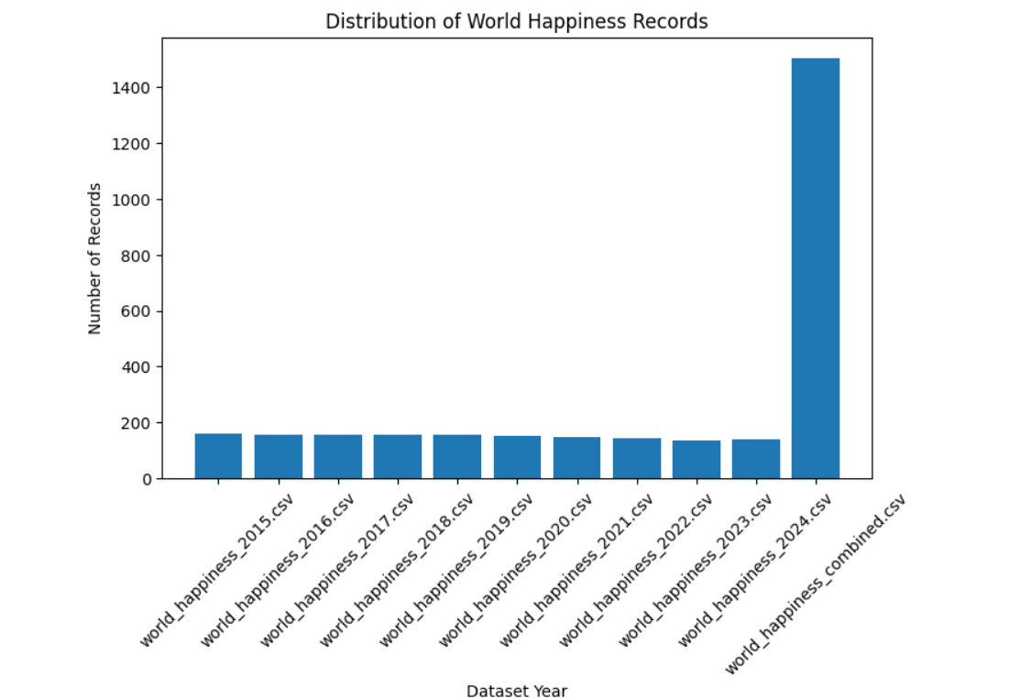
Mean ADR =
101.83112153446686

Median ADR =
94.575

Mode ADR =
0 62.0
Name: adr, dtype: float64

Standard Deviation =
50.5357902855456

Minimum ADR =
-6.38

Maximum ADR =
5400.0

Descriptive Statistics
lead_time stays_in_weekend_nights stays_in_week_nights \
count 119390.000000 119390.000000 119390.000000
mean 104.011416 0.927599 2.500302
std 106.863097 0.998613 1.908286
min 0.000000 0.000000 0.000000
25% 18.000000 0.000000 1.000000
50% 69.000000 1.000000 2.000000
75% 160.000000 2.000000 3.000000
max 737.000000 19.000000 50.000000

adults children babies adr
count 119390.000000 119386.000000 119390.000000 119390.000000
mean 1.856403 0.103890 0.007949 101.831122
std 0.579261 0.398561 0.097436 50.535790
min 0.000000 0.000000 0.000000 -6.380000
25% 2.000000 0.000000 0.000000 69.290000
50% 2.000000 0.000000 0.000000 94.575000
75% 2.000000 0.000000 0.000000 126.000000
max 55.000000 10.000000 10.000000 5400.000000

Average ADR by Hotel Type
hotel
City Hotel 105.304465
Resort Hotel 94.952930
Name: adr, dtype: float64
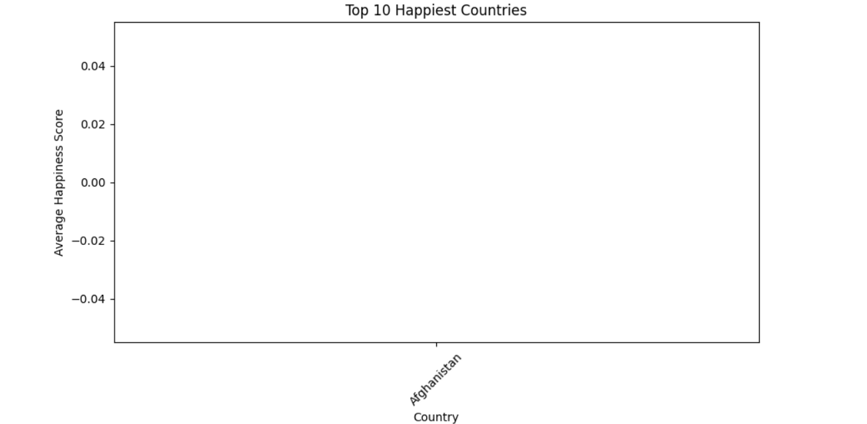

Country Happiness Aggregation
Ladder score
mean min max
Country
Afghanistan 1.7210 1.7210 1.7210
Albania 5.3042 5.3042 5.3042
Algeria NaN NaN NaN
Angola NaN NaN NaN
Argelia 5.3635 5.3635 5.3635
Argentina 6.1881 6.1881 6.1881
Armenia 5.4549 5.4549 5.4549
Australia 7.0569 7.0569 7.0569
Austria 6.9047 6.9047 6.9047
Azerbaijan 4.8934 4.8934 4.8934
Bahrain NaN NaN NaN
Bangladesh 3.8859 3.8859 3.8859
Belarus NaN NaN NaN
Belgium 6.8942 6.8942 6.8942
Belize NaN NaN NaN
Benin 4.3774 4.3774 4.3774
Bhutan NaN NaN NaN
Bolivia 5.7843 5.7843 5.7843
Bosnia and Herzegovina 5.8770 5.8770 5.8770
Botswana 3.3834 3.3834 3.3834
adults 1.000000 0.030447 0.018146
children 0.030447 1.000000 0.024030
babies 0.018146 0.024030 1.000000
previous_cancellations -0.006738 -0.024730 -0.007501
previous_bookings_not_canceled -0.107983 -0.021072 -0.006550
booking_changes -0.051673 0.048949 0.083440
agent -0.035594 0.041066 0.036184
company 0.207793 0.030931 0.019206
days_in_waiting_list -0.008283 -0.033273 -0.010621
adr 0.230641 0.324854 0.029186
required_car_parking_spaces 0.014785 0.056253 0.037383
total_of_special_requests 0.122884 0.081745 0.097889

is_repeated_guest previous_cancellations \
is_canceled -0.084793 0.110133
lead_time -0.124410 0.086042
arrival_date_year 0.010341 -0.119822
arrival_date_week_number -0.030131 0.035501
arrival_date_day_of_month -0.006145 -0.027011
stays_in_weekend_nights -0.087239 -0.012775
stays_in_week_nights -0.097245 -0.013992
adults -0.146426 -0.006738
children -0.032859 -0.024730
babies -0.008943 -0.007501
is_repeated_guest 1.000000 0.082293
previous_cancellations 0.082293 1.000000
previous_bookings_not_canceled 0.418056 0.152728
booking_changes 0.012092 -0.026993
agent 0.031527 -0.012488
company -0.244586 -0.184574
days_in_waiting_list -0.022235 0.005929
adr -0.134314 -0.065646
required_car_parking_spaces 0.077090 -0.018492
total_of_special_requests 0.013050 -0.048384

previous_bookings_not_canceled \
is_canceled -0.057358
lead_time -0.073548
arrival_date_year 0.029218
arrival_date_week_number -0.020904
arrival_date_day_of_month -0.000300
stays_in_weekend_nights -0.042715
stays_in_week_nights -0.048743
adults -0.107983
children -0.021072
babies -0.006550
is_repeated_guest 0.418056
previous_cancellations 0.152728
previous_bookings_not_canceled 1.000000
booking_changes 0.011608
agent 0.023252
company -0.208557
days_in_waiting_list -0.009397
adr -0.072144
required_car_parking_spaces 0.047653
total_of_special_requests 0.037824

booking_changes agent company \
is_canceled -0.144381 -0.083114 -0.020642
lead_time 0.000149 -0.069741 0.151464
arrival_date_year 0.030872 0.063457 0.259095
arrival_date_week_number 0.005508 -0.031201 -0.076760
arrival_date_day_of_month 0.010613 0.001487 0.044858
stays_in_weekend_nights 0.063281 0.140739 0.066749
stays_in_week_nights 0.096209 0.182382 0.182211
adults -0.051673 -0.035594 0.207793
children 0.048949 0.041066 0.030931
babies 0.083440 0.036184 0.019206
is_repeated_guest 0.012092 0.031527 -0.244586
previous_cancellations -0.026993 -0.012488 -0.184574
previous_bookings_not_canceled 0.011608 0.023252 -0.208557
booking_changes 1.000000 0.067010 0.122098
agent 0.067010 1.000000 0.350746
company 0.122098 0.350746 1.000000
days_in_waiting_list -0.011634 -0.055151 0.000411
adr 0.019618 -0.024695 0.086376
required_car_parking_spaces 0.065620 0.177353 -0.012916
total_of_special_requests 0.052833 0.034162 -0.098558

days_in_waiting_list adr \
is_canceled 0.054186 0.047557
lead_time 0.170084 -0.063077
arrival_date_year -0.056497 0.197580
arrival_date_week_number 0.022933 0.075791
arrival_date_day_of_month 0.022728 0.030245
stays_in_weekend_nights -0.054151 0.049342
stays_in_week_nights -0.002020 0.065237
adults -0.008283 0.230641
children -0.033273 0.324854
babies -0.010621 0.029186
is_repeated_guest -0.022235 -0.134314
previous_cancellations 0.005929 -0.065646
previous_bookings_not_canceled -0.009397 -0.072144
booking_changes -0.011634 0.019618
agent -0.055151 -0.024695
company 0.000411 0.086376
days_in_waiting_list 1.000000 -0.040756
adr -0.040756 1.000000
required_car_parking_spaces -0.030600 0.056628
total_of_special_requests -0.082730 0.172185

required_car_parking_spaces \
is_canceled -0.195498
lead_time -0.116451
Correlation Matrix
Ranking Happiness score GDP per capita \
Ranking 1.000000 -0.985595 -0.640628
Happiness score -0.985595 1.000000 0.626728
GDP per capita -0.640628 0.626728 1.000000
Social support -0.732372 0.740647 0.575636
Healthy life expectancy -0.666035 0.663172 0.613999
Freedom to make life choices -0.577408 0.589581 0.296704
Generosity -0.084970 0.103421 -0.077342
Perceptions of corruption -0.065137 0.061537 -0.092096
Ladder score -0.977167 NaN 0.768501
Year -0.072336 0.062231 -0.031451

Social support Healthy life expectancy \
Ranking -0.732372 -0.666035
Happiness score 0.740647 0.663172
GDP per capita 0.575636 0.613999
Social support 1.000000 0.547177
Healthy life expectancy 0.547177 1.000000
Freedom to make life choices 0.432652 0.354004
Generosity 0.019119 0.009944
Perceptions of corruption 0.094290 -0.203100
Ladder score 0.813538 0.758750
Year 0.033562 0.260827

Freedom to make life choices Generosity \
Ranking -0.577408 -0.084970
Happiness score 0.589581 0.103421
GDP per capita 0.296704 -0.077342
Social support 0.432652 0.019119
Healthy life expectancy 0.354004 0.009944
Freedom to make life choices 1.000000 0.276363
Generosity 0.276363 1.000000
Perceptions of corruption 0.121277 0.069411
Ladder score 0.644452 0.129989
Year 0.156980 0.117347

Perceptions of corruption Ladder score \
Ranking -0.065137 -0.977167
Happiness score 0.061537 NaN
GDP per capita -0.092096 0.768501
Social support 0.094290 0.813538
Healthy life expectancy -0.203100 0.758750
Freedom to make life choices 0.121277 0.644452
Generosity 0.069411 0.129989
Perceptions of corruption 1.000000 0.451722
Ladder score 0.451722 1.000000
Year 0.053750 NaN

Year
Ranking -0.072336
Happiness score 0.062231
GDP per capita -0.031451
Social support 0.033562
Healthy life expectancy 0.260827
Freedom to make life choices 0.156980
Generosity 0.117347
Perceptions of corruption 0.053750
Ladder score NaN
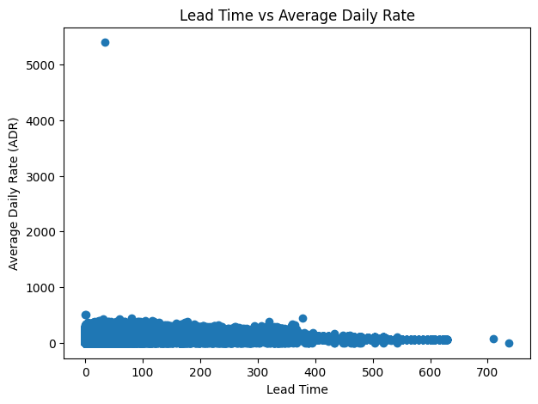
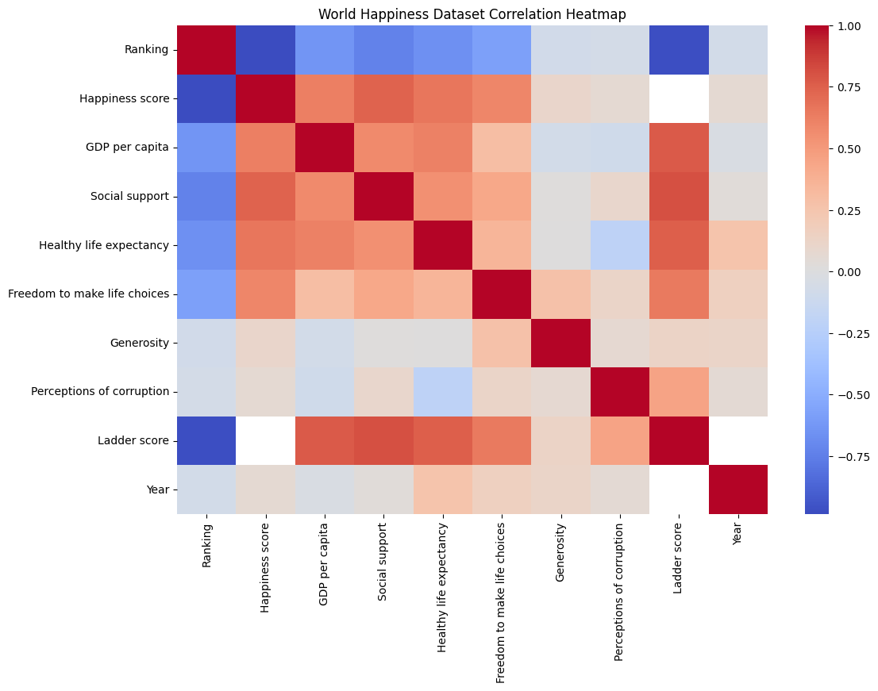

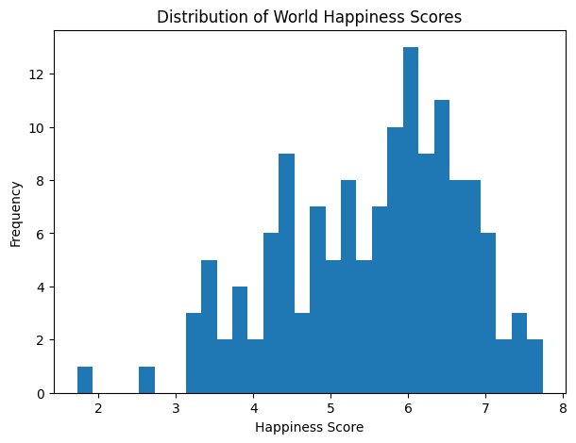

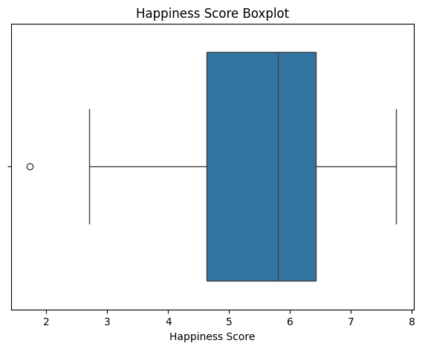

Year File Counts
Year_File
world_happiness_combined.csv 1502
world_happiness_2015.csv 158
world_happiness_2016.csv 157
world_happiness_2019.csv 155
world_happiness_2017.csv 155
world_happiness_2018.csv 155
world_happiness_2020.csv 152
world_happiness_2021.csv 148
world_happiness_2022.csv 145
world_happiness_2024.csv 140
world_happiness_2023.csv 137
Name: count, dtype: int64

Number of Unique Countries
175

Unique Countries
['Afghanistan' 'Albania' 'Argelia' 'Angola' 'Argentina' 'Armenia'
'Australia' 'Austria' 'Azerbaijan' 'Bahrain' 'Bangladesh' 'Belarus'
'Belgium' 'Belize' 'Benin' 'Bhutan' 'Bolivia' 'Bosnia and Herzegovina'
'Botswana' 'Brazil' 'Bulgaria' 'Burkina Faso' 'Burundi' 'Cambodia'
'Cameroon' 'Canada' 'Central African Republic' 'Chad' 'Chile' 'China'
'Colombia' 'Congo (Brazzaville)' 'Congo (Kinshasa)' 'Costa Rica'
'Croatia' 'Cyprus' 'Czech Republic' 'Denmark' 'Dominican Republic'
'Ecuador' 'Egypt' 'El Salvador' 'Estonia' 'Ethiopia' 'Finland' 'France'
'Gabon' 'Georgia' 'Germany' 'Ghana' 'Greece' 'Guatemala' 'Guinea' 'Haiti'
'Honduras' 'Hong Kong' 'Hungary' 'Iceland' 'India' 'Indonesia' 'Iran'
'Iraq' 'Ireland' 'Israel' 'Italy' 'Ivory Coast' 'Jamaica' 'Japan'
'Jordan' 'Kazakhstan' 'Kenya' 'Kosovo' 'Kuwait' 'Kyrgyzstan' 'Laos'
'Latvia' 'Lebanon' 'Lesotho' 'Liberia' 'Libya' 'Lithuania' 'Luxembourg'
'Macedonia' 'Madagascar' 'Malawi' 'Malaysia' 'Mali' 'Malta' 'Mauritania'
'Mauritius' 'Mexico' 'Moldova' 'Mongolia' 'Montenegro' 'Morocco'
'Mozambique' 'Myanmar' 'Namibia' 'Nepal' 'Netherlands' 'New Zealand'
'Nicaragua' 'Niger' 'Nigeria' 'Norway' 'Pakistan'
'Palestinian Territories' 'Panama' 'Paraguay' 'Peru' 'Philippines'
'Poland' 'Portugal' 'Qatar' 'Romania' 'Russia' 'Rwanda' 'Saudi Arabia'
'Senegal' 'Serbia' 'Sierra Leone' 'Singapore' 'Slovakia' 'Slovenia'
'Somalia' 'South Africa' 'South Korea' 'South Sudan' 'Spain' 'Sri Lanka'
'Sudan' 'Sweden' 'Switzerland' 'Syria' 'Taiwan' 'Tajikistan' 'Tanzania'
'Thailand' 'Togo' 'Trinidad & Tobago' 'Tunisia' 'Turkey' 'Turkmenistan'
'Uganda' 'Ukraine' 'United Arab Emirates' 'United Kingdom'
'United States' 'Uruguay' 'Uzbekistan' 'Venezuela' 'Vietnam' 'Yemen'
'Zambia' 'Zimbabwe' 'Czechia' 'Taiwan Province of China'
'Hong Kong S.A.R. of China' 'North Macedonia' 'State of Palestine'
'Turkiye' 'Gambia' 'Comoros' 'Congo' 'Eswatini' 'Somaliland region'
'Suriname' 'Trinidad and Tobago' 'Algeria' 'Puerto Rico' 'North Cyprus'
'Oman' 'Swaziland' 'Djibouti' 'Maldives']

Top 10 Countries by Average Happiness
Country
Finland 7.7407
Denmark 7.5827
Iceland 7.5251
Sweden 7.3441
Israel 7.3411
Netherlands 7.3194
Norway 7.3017
Luxembourg 7.1219
Switzerland 7.0602
Australia 7.0569
Name: Ladder score, dtype: float64

Number of Records by Year
Year_File
world_happiness_2015.csv 158
world_happiness_2016.csv 157
world_happiness_2017.csv 155
world_happiness_2018.csv 155
world_happiness_2019.csv 155
world_happiness_2020.csv 152
world_happiness_2021.csv 148
world_happiness_2022.csv 145
world_happiness_2023.csv 137
world_happiness_2024.csv 140
world_happiness_combined.csv 1502
Name: count, dtype: int64

Top 10 Countries by Happiness Score
Country Ladder score
1401 Finland 7.7407
1393 Denmark 7.5827
1414 Iceland 7.5251
1482 Sweden 7.3441
1420 Israel 7.3411
1455 Netherlands 7.3194
1461 Norway 7.3017
1438 Luxembourg 7.1219
1483 Switzerland 7.0602
1367 Australia 7.0569

Countries with Most Records
Country
Afghanistan 20
Albania 20
Argentina 20
Australia 20
Armenia 20
Bangladesh 20
Austria 20
Benin 20
Belgium 20
Bulgaria 20
Name: count, dtype: int64

CSV, Excel and JSON files exported successfully.

==============================================
EXPERIMENT COMPLETED SUCCESSFULLY
==============================================
Dataset Shape : (3004, 13)
Missing Values : 4513
Total Records : 3004
Average Happiness Score : 5.530882142857142
Minimum Happiness Score : 1.721
Maximum Happiness Score : 7.7407
Number of Countries : 175
Correlation Matrix Generated

RESULT

